[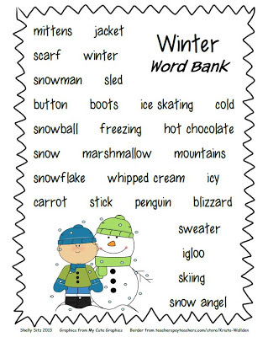](http://www.google.co.uk/url?sa=i&rct=j&q=&esrc=s&source=images&cd=&cad=rja&uact=8&ved=0CAcQjRxqFQoTCMXPm72r_sgCFclxFAodiDYDLA&url=http%3A%2F%2Fsmilingandshininginsecondgrade.blogspot.com%2F2013%2F01%2Fwinter-writing-freebie.html&psig=AFQjCNEOPOXdSeXIy-Jug1gZRLlwR_2N0g&ust=1446986649829059)